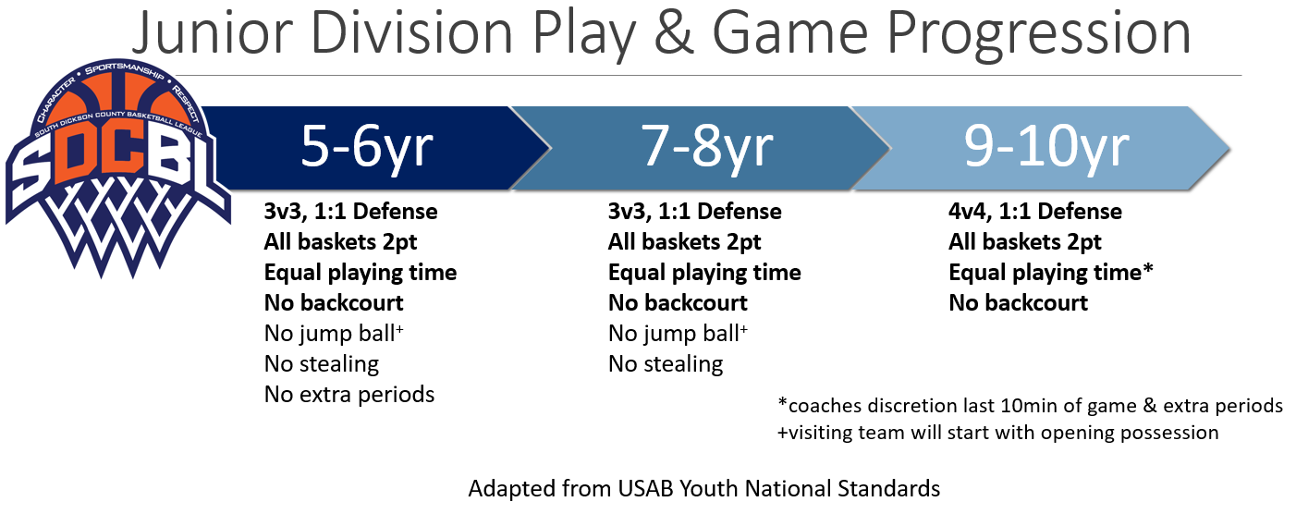
No stealing explained: A defensive player can not actively swat, grab, or otherwise take the ball away from an offensive player at any time. Offensive player will be subject to 5 second rule, defensive players can intercept, or otherwise deflect a pass to another offensive player. #respect
No backcourt explained: No defensive player(s) shall contest the ball or offensive player in the backcourt at any time. #sportsmanship

Game Play Variants (applies to both boys and girls unless otherwise specified)
5/6 Division 11/12 Division
Goal Height – 8’ Goal Height – 10’ standard
Basketball = 27.5” Basketball – 29.5” (B); 28.5” (G)
Free Throw Line = 10’ Free Throw – 15’ standard
7/8 Division 13/14 Division
Goal Height – 9’ Goal Height – 10’
Basketball = 28.5” Basketball – 29.5” (B); 28.5” (G)
Free Throw Line = 10’ Free Throw – 15’ standard
9/10 Division >15yrs
Goal Height – 10’ Standards apply
Basketball = 28.5”
Free Throw Line = 12’

Overtime Rules – (does not apply in 5/6 except during tourney) 2min period w/jump ball start. Team fouls carry over and clock stops per standard rules. If 2nd OT is needed, free throws will be shot by same players on the floor. Visiting team will shoot free throws first, followed by other team. FT rounds will persist (alternating starts) until game is decided. Rules should be explained to everyone at start.

